INFOTACT SOLUION
WAF SETUP & BASELINE TESTING
TASK-2

JAGATHEESWARAN S
jagatheessivagami@gmail.com
PROJECT-2
Web Application Firewall (WAF) Rule Development and Evasion Testing Lab Objectives :
- To deploy and configure a Web Application Firewall in a test environment.
- To understand the network architecture and traffic flow through the WAF.
- To capture baseline data for normal web application traffic.
- To verify WAF functionality without any custom rules applied.
- To ensure no legitimate traffic is blocked during baseline testing.
VM & Web Server Setup (Apache):
Step -1 Update the system
Cmd : sudo apt update && sudo apt upgrade -y
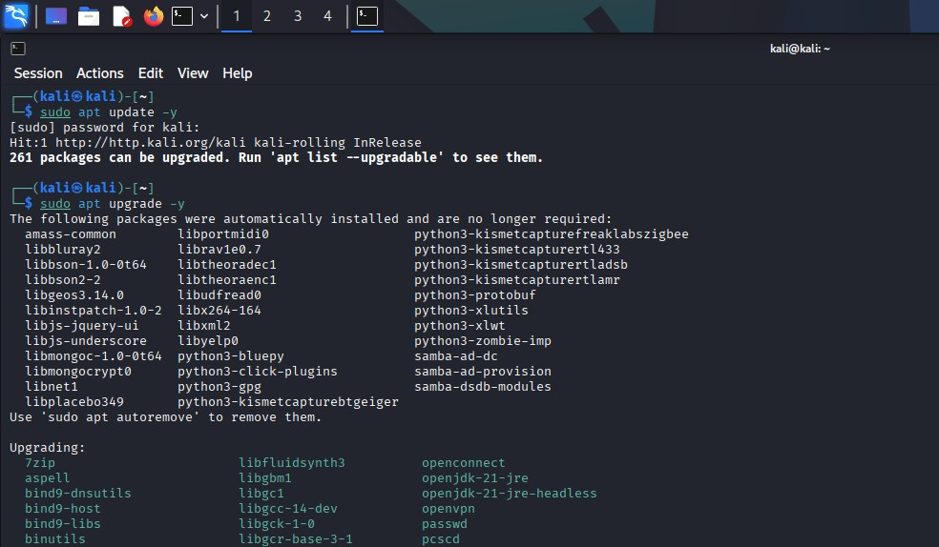
Step -2 Update & Install Apache
- Installs the Apache HTTP Server.
CMD: sudo apt update && sudo apt install apache2 -y
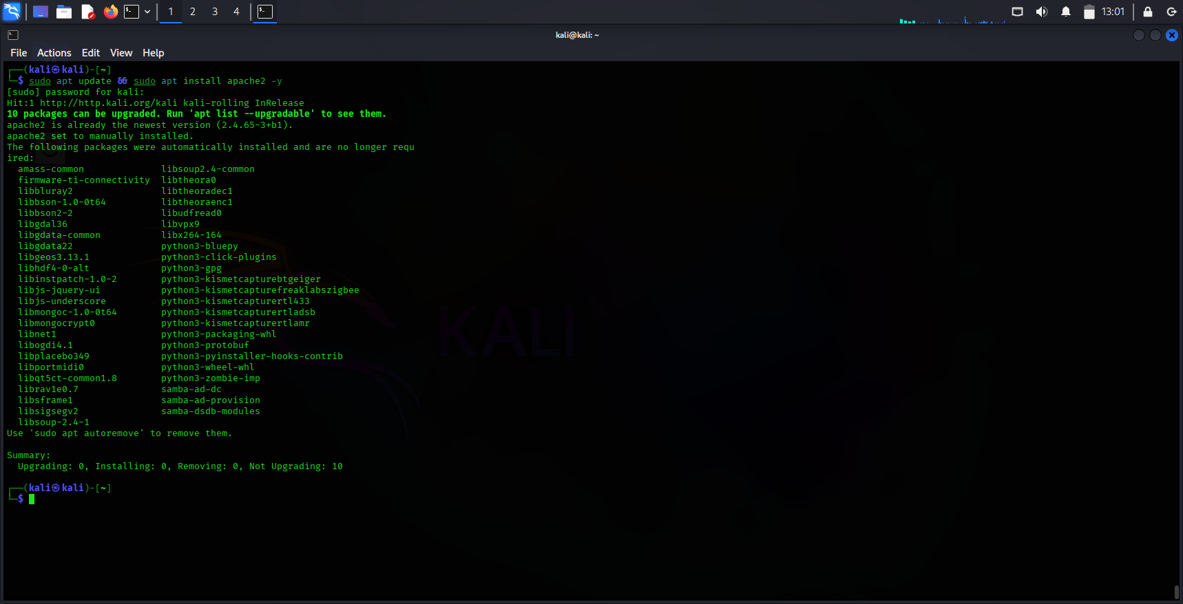
- sudo systemctl enable --now apache2
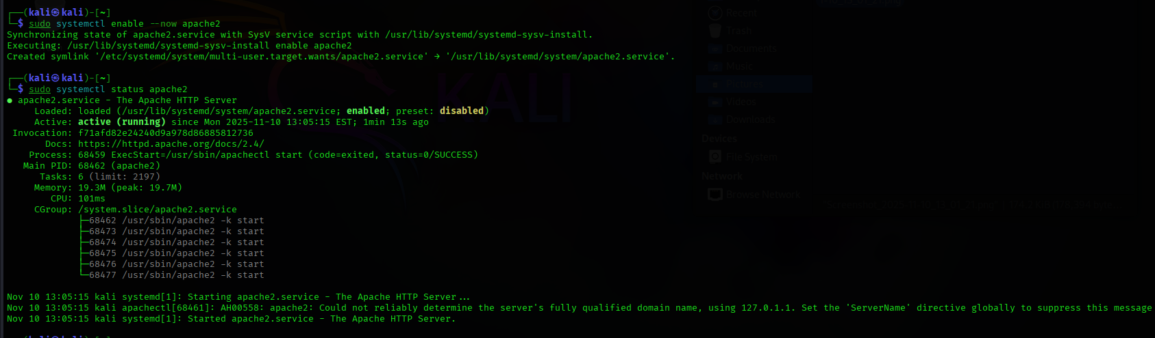
- sudo ufw allow 'Apache'
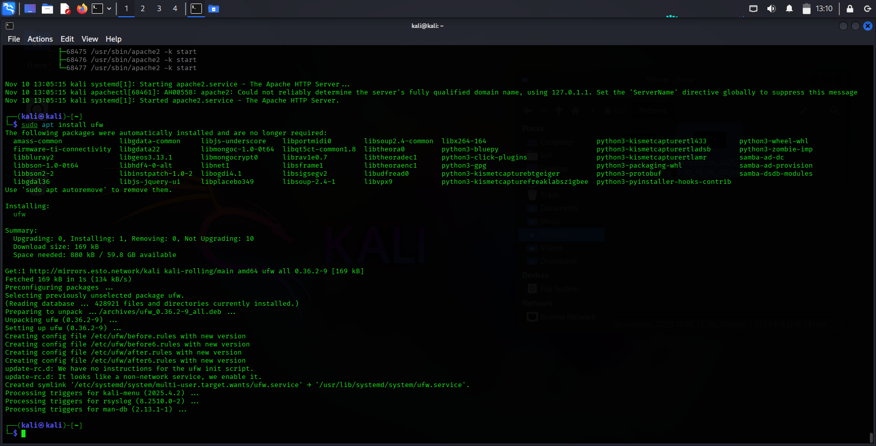

- Verify by visiting http:/// in browser.
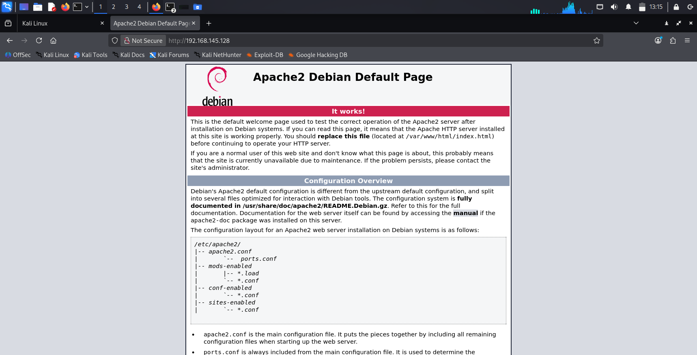

Step -3 Install ModSecurity
- Installs the ModSecurity module.

CMD : sudo apt install libapache2-mod-security2 -y
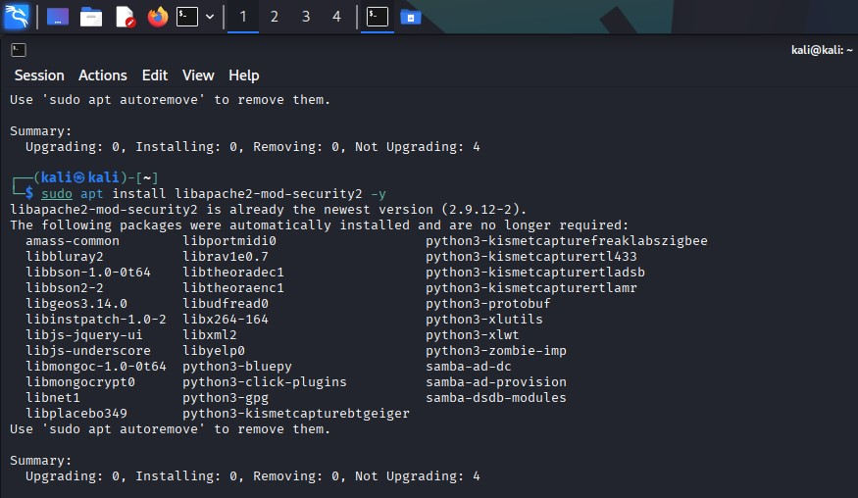
Step -4 Enable Module
- Enables the WAF and header modules.
CMD : sudo a2enmod security2 headers
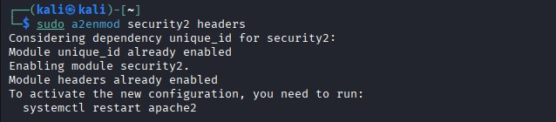
Step -5 Configure ModSecurity
- Copies the recommended template.
CMD : sudo cp /etc/modsecurity/modsecurity.conf-recommended
/etc/modsecurity/modsecurity.conf
Step -6 Set Engine Mode
- Enables blocking mode for testing
CMD : Modify /etc/modsecurity/modsecurity.conf
Change SecRuleEngine DetectionOnly to SecRuleEngine On
Step -7 Install CRS
- Installs the OWASP Core Rule Set
CMD : sudo apt install modsecurity-crs -y

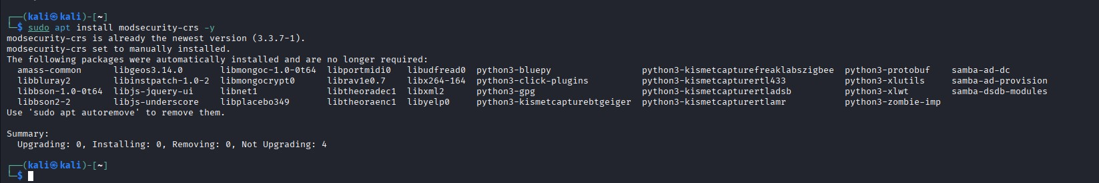
Step -8 Restart Apache
- Applies the changes.
CMD : sudo systemctl restart apache2

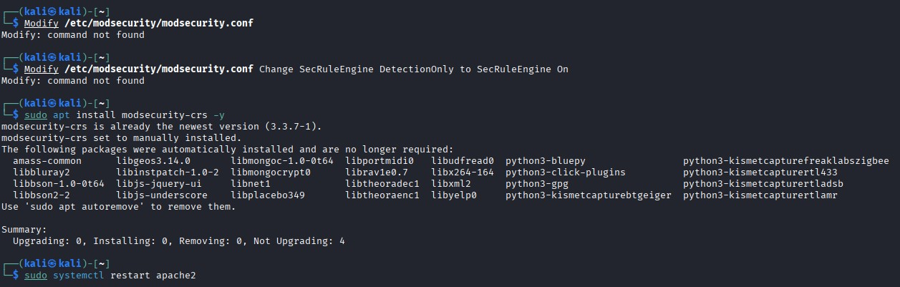

Install and Configure DVWA:
Step -1 Install PHP & MySQL
- Installs dependencies for DVWA.
CMD : sudo apt install php php-mysql mysql-server -y
Step -2 Download DVWA
- Clones the DVWA repository.
- Git link : https://github.com/digininja/DVWA.git /var/www/html/dvwa
CMD : sudo git clone https://github.com/digininja/DVWA.git
/var/www/html/dvwa
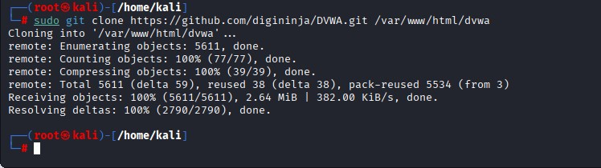
Configure Apache :
- Ensure DVWA is accessible and MySQL is set up for DVWA's database.

Baseline Attack (SQLi & XSS) :
Basic SQLi:
- Blocked (HTTP 403 Forbidden). WAF logs show a rule ID from the CRS (e.g., 942100 for SQLi).
CMD : curl 'http://dvwa/vulnerabilities/sqli/?id=1%27+OR+1=1-- ' Basic XSS :
- Blocked (HTTP 403 Forbidden). WAF logs show a rule ID from the CRS (e.g., 941100 for XSS).
CMD : curl 'http://dvwa/vulnerabilities/xss_s/?name=<script>alert(1)</script>'

Custom Rule Creation and Specific Testing :
WAF Setup & Rule Creation:
- The focus shifts to creating high-priority, specific rules to supplement the generic CRS. Create a new custom rules file: /etc/modsecurity/owasp-crs/rules/REQUEST999-CUSTOM-INFOACT.conf.

Custom Rule for Basic SQL Injection :
# ID: 999100 - Basic SQLi Custom Block
SecRule ARGS|REQUEST_BODY "@rx (\s(union|select|insert|update)\s|\s?--\s?|\/\*)" \
"id:999100,\ phase:2,\ block,\ log,\
msg:'[INFOACT CUSTOM] Simple SQL Keyword Detected',\
tag:'attack-sqli',\ t:lowercase,t:urlDecodeUni"
Custom Rule for Basic XSS Blocking :
# ID: 999101 - Basic XSS Custom Block
SecRule ARGS|REQUEST_BODY "@rx (<script>|onerror=|javascript:|eval\()" \
"id:999101,\ phase:2,\ block,\ log,\
msg:'[INFOACT CUSTOM] Simple XSS Tag/Function Detected',\
tag:'attack-xss',\ t:htmlEntityDecode,t:urlDecodeUni,t:lowercase"

Command to Apply Rules: sudo systemctl reload apache2

Testing with Automation (sqlmap) :
- Use the automated tool sqlmap to ensure the custom rule provides specific blocking feedback.
# This test will generate multiple specific SQLi payloads.
# --level 5 --risk 3 attempts advanced techniques. sqlmap -u "http://dvwa/vulnerabilities/sqli/?id=1&Submit=Submit" \
--cookie="security=low; PHPSESSID=..." --level 5 --risk 3
- ModSecurity should block the advanced payloads generated by sqlmap. The logs should show rule 999100 being triggered.

WAF Setup & Rule Creation:

- Analyze the WAF logs to understand what attacks were blocked and how. Then, create rules specifically targeting common evasion techniques.

CMD : sudo grep "ModSecurity" /var/log/apache2/error.log | grep "id \"9"

Advanced Rule for Double Encoding Evasion :
- This rule applies two layers of URL decoding and then checks for keywords, defeating one common evasion method.
# ID: 999102 - Double URL Decode SQLi Block
SecRule ARGS|REQUEST_BODY "@rx (select|union|update)" \
"id:999102,\ phase:2,\ block,\ log,\
msg:'[INFOACT CUSTOM] Double Encoded Payload Detected',\ tag:'evasion-decode',\
# Apply transformation twice to defeat double encoding t:urlDecodeUni,t:urlDecodeUni,\ t:lowercase"
Attempt Evasion (Double URL Encoding) :
Use a double-encoded XSS payload to see if the new, hardened ruleset prevents the bypass.
- Original : <script>alert(1)</script>
- Single Encoded : %3cscript%3ealert%281%29%3c%2fscript%3e
- Double Encoded : %253cscript%253ealert%25281%2529%253c%252fscript%253e

# Attack command attempting to bypass WAF curl
'http://dvwa/vulnerabilities/xss_s/?name=%253cscript%253ealert%25281%2529 %253c%252fscript%253e'
Rule Hardening and Final Verification :

WAF Setup & Rule Creation :
Refine the rules by:
- Checking for False Positives (FPs): If any legitimate application traffic was blocked, create an exclusion (ctl:ruleRemoveById...).

- Ensuring Normalization is robust: All necessary transformations (t:lowercase, t:htmlEntityDecode, t:jsDecode, etc.) are applied before pattern matching.

Final Rule Hardening Example (Input Validation)
• Harden input validation for a specific parameter (e.g., _{id}) to only allow digits, preventing any injection payload.
# ID: 999103 - Strict Input Validation for ID parameter
SecRule ARGS:id "!@rx ^\d+$" \
"id:999103,\ phase:2,\ block,\ log,\
msg:'[INFOACT CUSTOM] Strict Input Validation Failed on ID',\ tag:'hardening-validation'"
Command to Apply Final Rules: sudo systemctl reload apache2

